**Project Design Phase-II**

**Data Flow Diagram & User Stories**

|  |  |
| --- | --- |
| Date | 06 May 2023 |
| Team ID | NM2023TMID11250 |
| Project Name | Advanced breast cancer prediction with deep learning |

**Data Flow Diagrams:**

A Data Flow Diagram (DFD) is a traditional visual representation of the information flows within a system. A neat and clear DFD can depict the right amount of the system requirement graphically. It shows how data enters and leaves the system, what changes the information, and where data is stored.

**Example:** [**(Simplified)**](https://developer.ibm.com/patterns/visualize-unstructured-text/)

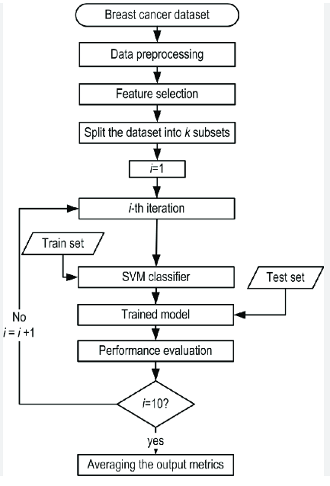

**User Stories**

| **User Type** | **Functional Requirement (Epic)** | **User Story Number** | **User Story / Task** | **Acceptance criteria** | **Priority** | **Team Member** |
| --- | --- | --- | --- | --- | --- | --- |
| Customer (use readings) | Readings | USN-1 | As a user, I can easily to know the status of breast cancer easily | I can check my status | High | Prithiga |
| Customer (application user) | login | USN-2 | As a user, I will surely conform the breast cancer is present or not | I can check cancer is present or not | High | pavin |
| Customer (image user) | image | USN-3 | As a user, I can easily upload my image and the reading to find the level of cancer | I can check while upload an image | Low | Sridhar |
| Customer (status user) | readings | USN-4 | As a user, it was easy and advanced process to check the status of cancer | I can check the status | Medium | Dharshini |